FOCP ASSIGNMENT 1

MODULE 1
Ques 3
add two integers

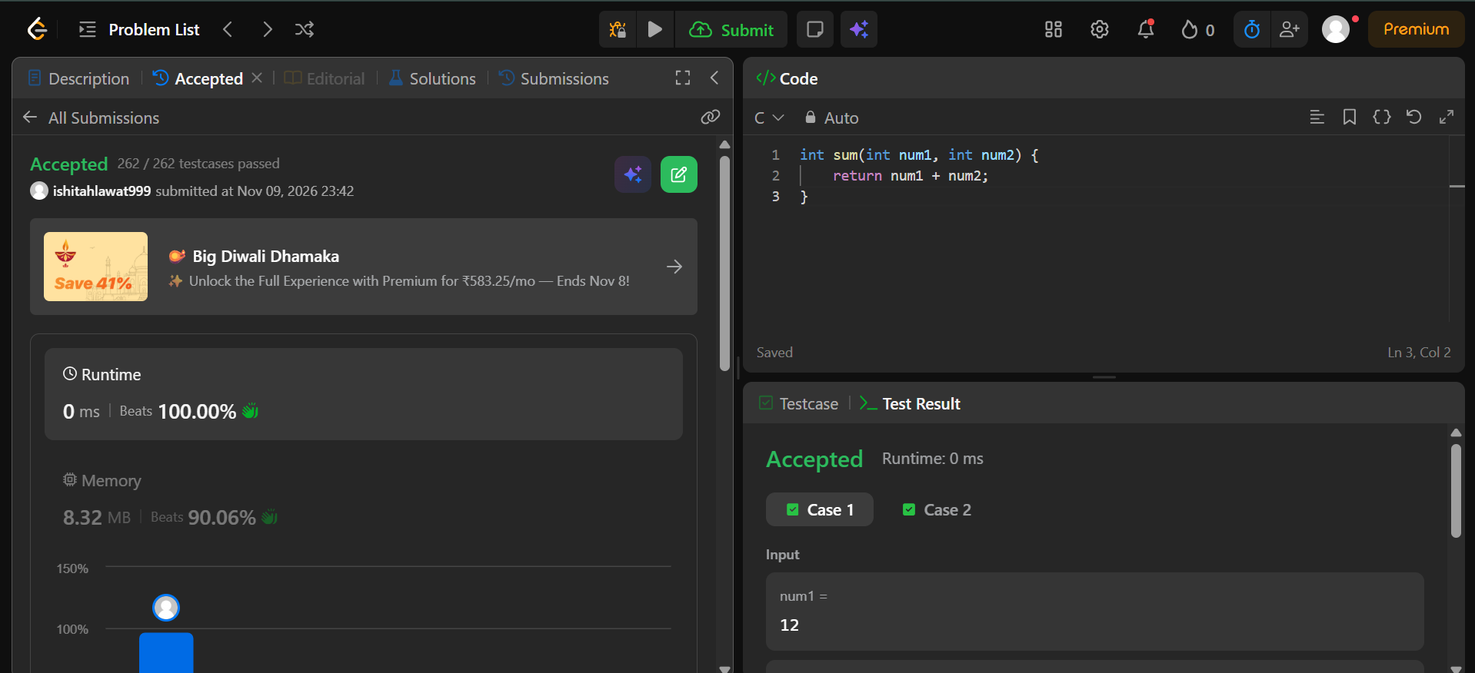

int sum(int num1, int num2) {
return num1 + num2;
}

